Use Case 2:

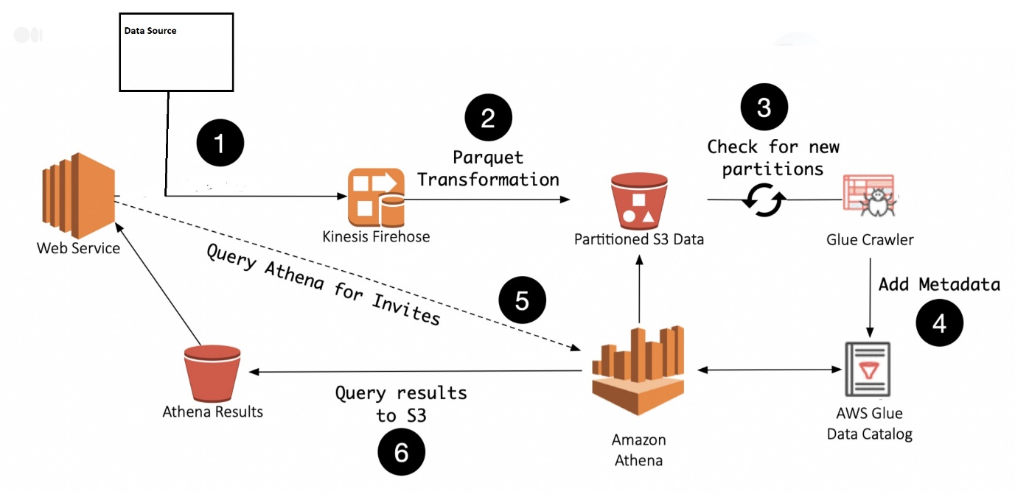

We could use the following AWS services to solve the problem :

AWS Kinesis Firehose

AWS S3

AWS Glue Catalog

AWS Glue Crawler

AWS Athena

AWS Kinesis Firehose is a powerful and highly scalable data streaming service. It can stream large amounts of data and in batches to s3 as partitioned data. Firehose is a service that handles loading streaming data and pushing it into data stores and analytic tools. We now have an event stream with a minimal setup that outputs data to S3 in a predictable location.

Firehose is a managed service. It is highly available and hence can manage sporadic events.

Glue Crawler should be configured to crawl the data in s3. The crawler traverses an S3 location and can update table schema to discover new columns as well as partitions in your data. With the ability to schedule a crawler to run every few minutes, the service can have data ingested from Firehose, sent to S3, and discovered by the crawler made available as a single queryable event stream.

Glue Crawler updates the Glue Catalog which can then be queried by the API Service using AWS Athena.

Monitoring can be set up on Firehose using bottlenecks metrics which will report the metrics to cloudwatch. Alarms can be created to monitor the streams from cloudwatch.

**New requirements:**

Code updates need to be pushed out frequently. This needs to be done without the risk of stopping a data update already being processed, nor a data response from being lost.

* This can be addressed by using a distributed messaging services like AWS MSK (Managed Kafka) or Celery. The benefit of using these services would be even if our app server crashes our job queue will still remain. They will keep track of the work you send to it in a database back-end.

For development and staging purposes, you need to start up a number of scaled-down versions of the system.

* With Terraform, we can spin infrastructure with different parameters in different environments. This makes it possible to create scaled-down versions of the system for development or staging.